My Derwent Hill Adventure…

Z:\DERWENT HILL\MARKETING\Photos\Derwent Hill Image Bank from Hemisphere\Derwent Hill Image Bank Disc 1\Building & Environs\Hi Res_J5T4852.tif

Name………………

Before your Derwent Hill adventure, try and find out the following information…

My group number is…

My dormitory is called…

The activities we plan to do include…

The activity I am most looking forward to is…

Typical Derwent Hill day…

My daily routine at Derwent Hill…

Breakfast at 8:00 am

1st activity from 9:30am – 12:30pm

Lunch

2nd activity from 1:30pm – 4:30pm

Tidy equipment / free time / diary time from 4:30pm – 5:25pm

Evening meal 5:30pm

3rd activity from 6:45 onwards

Your leaders will set bed time

DAILY RECORD

|  |  |  |  |  |
| --- | --- | --- | --- | --- |
|  |  | ACTIVITY  &  LOCATION / LANDSCAPE | THE  WEATHER | A WORD or TWO  TO DESCRIBE YOUR DAY |
| MONDAY | AFTERNOON |  |  |  |
| EVENING |  |  |  |
| TUESDAY | MORNING |  |  |  |
| AFTERNOON |  |  |  |
| EVENING |  |  |  |
| WEDNESDAY | MORNING |  |  |  |
| AFTERNOON |  |  |  |
| EVENING |  |  |  |
| THURSDAY | MORNING |  |  |  |
| AFTERNOON |  |  |  |
| EVENING |  |  |  |
| FRIDAY | MORNING |  |  |  |

C:\Users\sue.walker\AppData\Local\Microsoft\Windows\Temporary Internet Files\Content.IE5\8L6O0M0T\MC900434413[1].wmf

Starting Out

Monday

Choose a word from each pair that best describes your first impressions of Derwent Hill…

Big / Small Old / New Smart / Scruffy Bright / Dull

Town / Countryside Friendly / Unfriendly Lively / Quiet

Now write a sentence that describes how you felt when you arrived…

Record the equipment you have been given for the week…

* Peg Number / Rucksack =
* Waterproof Jacket =
* Waterproof Trousers =
* Boots =

What did you and your group do this afternoon? What has been the best part about today?

Find out what activities you are doing tomorrow? Draw a face that best fits how you feel…

My First Whole Day

Tuesday

Think back to Monday night, what activity did you do? Record it and use a word to describe it…

Inspection!C:\Users\sue.walker\AppData\Local\Microsoft\Windows\Temporary Internet Files\Content.IE5\EP4R62ZJ\MC900334652[1].wmf

Record your dormitory score e

What did you enjoy doing most of all today? Include a picture too.

Don’t forget to record your activities on your daily record.

Half Way

Wednesday

Think back to Tuesday night, what activity did you do? Record it and use a word to describe it…

Inspection!C:\Users\sue.walker\AppData\Local\Microsoft\Windows\Temporary Internet Files\Content.IE5\EP4R62ZJ\MC900334652[1].wmf

Record your dormitory score

What did you enjoy doing most of all today? Include a picture too.

Don’t forget to record your activities on your daily record.

Last Full Day

Thursday

Think back to Wednesday night, what activity did you do? Record it and use a word to describe it…

Inspection!C:\Users\sue.walker\AppData\Local\Microsoft\Windows\Temporary Internet Files\Content.IE5\EP4R62ZJ\MC900334652[1].wmf

Record your dormitory score

What did you enjoy doing most of all today? Include a picture too.

Don’t forget to record your activities on your daily record.

Facing the Challenge!

Thursday

Think about all the challenges you have faced this week. Write them in the spaces on the ladder. Put the most challenging at the top and the least challenging at the bottom.

C:\Users\sue.walker\AppData\Local\Microsoft\Windows\Temporary Internet Files\Content.IE5\VFCE31NK\MC900340260[1].wmf

At the left side of the ladder give the challenge a happy or unhappy face. At the right side of the ladder use a describing word to express how you felt afterwards. For your biggest challenge, did anybody else help you achieve it?

Think about the activities you have done today. What gets the thumbs up? What gets the thumbs down?

C:\Users\sue.walker\AppData\Local\Microsoft\Windows\Temporary Internet Files\Content.IE5\IYO1EUBO\MC900440412[1].wmf

C:\Users\sue.walker\AppData\Local\Microsoft\Windows\Temporary Internet Files\Content.IE5\PEGO2HYZ\MC900437791[1].wmf

Activity Enjoyment Scale

**Activity…………………………………………….**

Mark on the scale how much you enjoyed the activity

C:\Users\sue.walker\AppData\Local\Microsoft\Windows\Temporary Internet Files\Content.IE5\PEGO2HYZ\MC900423171[1].wmf C:\Users\sue.walker\AppData\Local\Microsoft\Windows\Temporary Internet Files\Content.IE5\IYO1EUBO\MC900423167[1].wmfBrilliant!...................................................................................Disliked it!

Why?

What did you learn?

Activity Enjoyment Scale

Put your activities in order of enjoyment on the ‘Brilliant’ to ‘Disliked it’ scale

C:\Users\sue.walker\AppData\Local\Microsoft\Windows\Temporary Internet Files\Content.IE5\PEGO2HYZ\MC900423171[1].wmf C:\Users\sue.walker\AppData\Local\Microsoft\Windows\Temporary Internet Files\Content.IE5\IYO1EUBO\MC900423167[1].wmf Brilliant!..............................................................................Disliked it!

Why was ……………………………………. your favourite activity?

If I had a camera I would have taken a photo when…..

# Working Together

On the left and right hands, write down

C:\Users\sue.walker\AppData\Local\Microsoft\Windows\Temporary Internet Files\Content.IE5\VFCE31NK\MC900070936[1].wmfall the times you have been helped by others.

On the top and bottom hands, write down all

the things you have done to help others.

# Proudest Moment

# I felt proud when…

# Something I did that I thought I could not do was…

# I felt proud of my friend when…

# Biggest Challenge

# My biggest challenge was when…

# Completing this challenge made me feel…

# The people that helped me are…

New Experiences

## Find a quiet space and reflect on all your new experiences at Derwent Hill…

1person I would like to thank is…

2 new places I have discovered are…

**1**

**2**

3 things I have learnt about the Lake District are…

**1**

**2**

**3**

4 things I have learnt about working in a team are…

**1**

**2**

**3**

**4**

5 things I have done that have helped me to be independent are…

**1**

**2**

**3**

**4**

**5**

Skills and Equipment

Have a think about all the new skills you have learnt this week. Make a list of the ones you think are important and you could use again…

Have any of the skills allowed you to be more independent? Make a note of these and how you will use them back home and at school…

Think about all the equipment you have used this week. What has been your favourite piece? In the space below, describe what it is used for and how it works…

Write a postcard to yourself which will remind you of all the exciting things you have done and learnt about whilst at Derwent Hill.

Place Stamp Here

**Place stamp Here**

**Your text here**

**To Me,**

What would you award yourself a gold medal for?

Below the medal, write down what you did to achieve it.

C:\Users\sue.walker\AppData\Local\Microsoft\Windows\Temporary Internet Files\Content.IE5\VFCE31NK\MC900139591[1].wmf

……………………………………………………………………………………………………………

……………………………………………………………………………………………………………

……………………………………………………………………………………………………………

My Achievements at Derwent Hill

This week I have…

I also shared a dormitory with…

I ate ……………………………………………. for the first time and enjoyed it

The activity I enjoyed most was

……………………………………………………………………………………

This was because

……………………………………………………………………………………

The activity I enjoyed most when working with my team was

……………………………………………………………………………………

This was because

……………………………………………………………………………………

I felt very proud when I

……………………………………………………………………………………

Something that I did that I didn’t think I would be able to, was

……………………………………………………………………………………

……………………………………………………………………………………

Identify 3 goals that you hope to achieve at Derwent Hill

Goal for the morning…

C:\Users\sue.walker\AppData\Local\Microsoft\Windows\Temporary Internet Files\Content.IE5\NWWH3PXV\MC900389360[1].wmf

Goal for the afternoon…

C:\Users\sue.walker\AppData\Local\Microsoft\Windows\Temporary Internet Files\Content.IE5\EP4R62ZJ\MC900389360[1].wmf

Goal for the evening…

C:\Users\sue.walker\AppData\Local\Microsoft\Windows\Temporary Internet Files\Content.IE5\EP4R62ZJ\MC900389360[1].wmf

When setting yourself some goals, make sure they are achievable. Spend time afterwards reviewing them.

Set your

goals

Review your goals

Try your

hardest

A FEW TIPS TO HELP YOU ENJOY YOUR WEEK OF ADVENTURE!

C:\Users\sue.walker\AppData\Local\Microsoft\Windows\Temporary Internet Files\Content.IE5\EP4R62ZJ\MC900232180[1].wmf

It might be sunny and warm at Derwent Hill, but at the top of a mountain or out on the lake……the weather can be much colder. Layers work best – put more clothes on as it gets cold. Don’t forget to pack your waterproofs.

C:\Users\sue.walker\AppData\Local\Microsoft\Windows\Temporary Internet Files\Content.IE5\EP4R62ZJ\MC900053398[1].wmf

C:\Users\sue.walker\AppData\Local\Microsoft\Windows\Temporary Internet Files\Content.IE5\EP4R62ZJ\MC900215358[1].wmfC:\Users\sue.walker\AppData\Local\Microsoft\Windows\Temporary Internet Files\Content.IE5\00SQ7LKV\MC900048792[1].wmf

Food is fuel: start with a filling breakfast, have a good packed lunch followed by a wholesome tea at 5:30pm.

C:\Users\sue.walker\AppData\Local\Microsoft\Windows\Temporary Internet Files\Content.IE5\EP4R62ZJ\MC900288988[1].wmf

Groups should keep together and go at the pace of the slowest member. Always follow the Countryside Code. Explore your surroundings and use your senses to discover new things. Don’t be afraid to take sensible risks. Taking risks can increase your chance of being healthy, interesting and knowledgeable. Your memories and experiences will stay with you forever.

The Countryside Code

The Lake District has special wild places which like many other green areas need to be looked after. Green areas close to where you live could include country parks, beaches, woodlands, rivers and forests.

The Countryside Code has been set up for us all to follow when we are enjoying the great outdoors.

Leave gates as you find them

Take all your litter home with you

Keep to footpaths

Avoid climbing over fences, hedges and walls

Protect wildlife, plants and trees

Don’t light fires

Don’t pollute streams and rivers

C:\Users\sue.walker\AppData\Local\Microsoft\Windows\Temporary Internet Files\Content.IE5\00SQ7LKV\MC900319990[1].wmf

Map of the United Kingdom

Can you mark on the map where you live and where Derwent Hill is?

C:\Users\sue.walker\AppData\Local\Microsoft\Windows\Temporary Internet Files\Content.IE5\TKS96F46\MC900329243[1].wmf

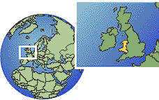

Here’s some information about Derwent Hill…

Derwent Hill is in the small village of Portinscale close to the town of Keswick. Your journey from Sunderland on the East side of England brought you over the Pennines (a mountain range) a distance of approximately 98 miles to Cumbria in the North West.

Derwent Hill is built on a grassy hill thought to have been a glacial feature. The house is set in 28 acres of lawns and gardens, woodland and grazing land for sheep. The River Derwent leaves Derwent Water and flows around the grounds eventually entering Lake Bassenthwaite 7 miles downstream.

Derwent Hill was built between June 1809 and August 1811. The Slack family owned Derwent Hill from the late 1800’s for over 100 years. The Slack family crest takes pride of place over the fire place in the Games room. Go and have a look…

Helmet Crescent Snail

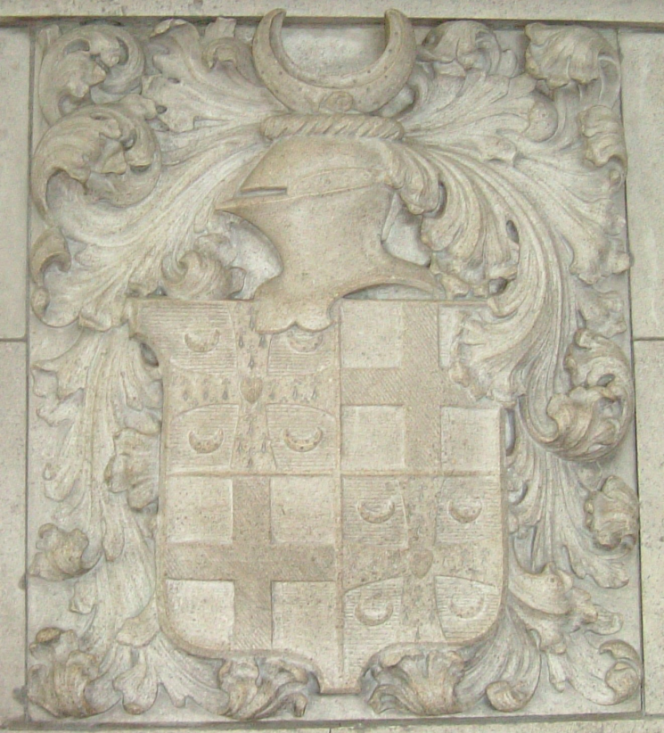

Heart Cross (Patte) Cross (Hummet)

There are four main parts to the crest: the crescent, the snail, the helmet and the hearts at the centre of the crosses. The crescent represents ‘hope of a greater glory’, or in other words constantly attempting to better oneself. This is done through deliberation and perseverance and is represented by the snail, which sits just in front of the crescent. Incidentally this is one of the few snails to be seen on family crests in Britain. The helmet represents wisdom and security in defence, strength, protection and invulnerability, whilst the heart at the centre of the two crosses show charity and sincerity. The Patte cross represents a military honour and the Hummet cross demonstrates Christian roots.

Before Sunderland City Council purchased Derwent Hill in 1662 it was run by the Church of England for final year students studying biology and geography!

Since 1662, 100,000+ young people from Sunderland have visited Derwent Hill to take part in an Outdoor Education Course. Have any of your grandparents, mums and dads, brothers and sisters been to Derwent Hill…?

Back home in Sunderland, what’s next…

If you enjoyed being attached to a rope and would like to do more climbing contact

The Sunderland Wall, Climbing Centre

C:\Users\sue.walker\AppData\Local\Microsoft\Windows\Temporary Internet Files\Content.IE5\8L6O0M0T\MC900383892[1].wmf 0191 514 4234 OR www.sunderlandclimbingcentre.co.uk

If you loved being on the lake and in the streams whilst canoeing, kayaking, sailing and gorge scrambling contact

Adventure Sunderland, Marine Activities Centre

C:\Users\sue.walker\AppData\Local\Microsoft\Windows\Temporary Internet Files\Content.IE5\8L6O0M0T\MC900383892[1].wmf 0191 514 4721

Governing Bodies of all the associations

BMC - Climbing, Hill walking and Mountaineering. [www.thebmc.co.uk](http://www.thebmc.co.uk)

RYA – Sailing. [www.rya.org.uk](http://www.rya.org.uk)

BCU – Canoeing and Kayaking. [www.bcu.org.uk](http://www.bcu.org.uk)